**Report of Lab-2 Assignment (CS-560)**

**By Vidhi Shah**

**Student ID: 16178723**

Complete the following tasks:   
1. Implement a Mobile Client Application using either (1) Javascript, HTML5, CSS3, WebGL, jQuery Mobile or (2) Android App technologies.   
2. Use existing Web Services (e.g., Google Map Services, Weather Services) for the application.

Ans:

I have made an application using jQuery in fsfiddle which shows weather of different location in Celsius unit on page load event.

**LINK IS:**

<http://jsfiddle.net/vidhishah123/NmCRr/2/>

**figure:1 : screenshot of jsfiddle window**

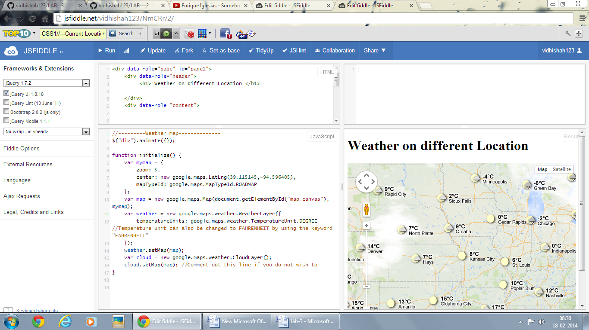

**Figure 2: screenshot of opera mobile emulator**

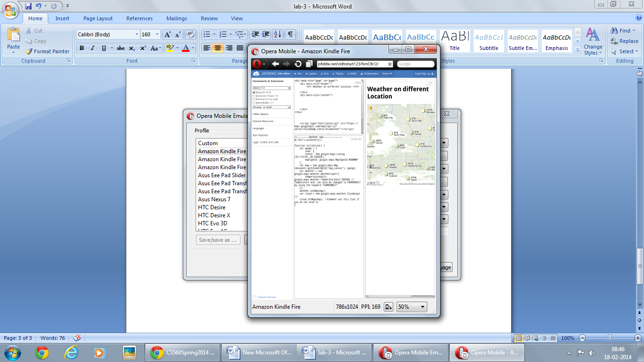

End